- Match to finish the sentences.
- A fairy looks like …
- A dragon looks like …
- A unicorn looks like …
- A leprechaun looks like …
- A mermaid looks like …
- a man.
- a woman (with a fish tail).
- a lizard.
- a small girl (with wings).
- a horse (with a horn).

- Fill in the sentences with the correct word from the table.
tooth gold sea forests (3x) hat job caves green present rainbow

Dragons live in __________, mountains or __________. Leprechauns wear __________ clothes and a __________. Leprechauns have a pot of __________ at the end of the __________.
Fairies live in __________. Each fairy has a special __________. The Tooth Fairy brings a __________ when your __________ falls out. Mermaids live in the __________. Unicorns live in __________.

- What can these magical beings do? Choose the correct verb and finish the sentences using “can”.

give sing fly (2x) heal breathe (2x) speak change

- Mermaids can speak underwater.
- Mermaids ____________________ underwater.
- Mermaids ____________________ beautifully.
- Dragons ____________________ fire.
- Dragons ____________________.
- Unicorns ____________________ injuries.
- Fairies ____________________.
- Fairies ____________________ things into something else.
- Leprechauns ____________________ you three wishes.

- Answer the questions. Use can or can’t.
Example: Can leprechauns fly? No, they can’t.
Can leprechauns give you three wishes? Yes, they can.

- Can dragons breathe fire? _______________________________________
- Can fairies speak underwater? _______________________________________
- Can unicorns heal injuries? _______________________________________
- Can fairies fly? _______________________________________
- Can mermaids sing beautifully? _______________________________________
- Can dragons breathe underwater? _______________________________________

- Fill in the crossword with English adjectives from the article.
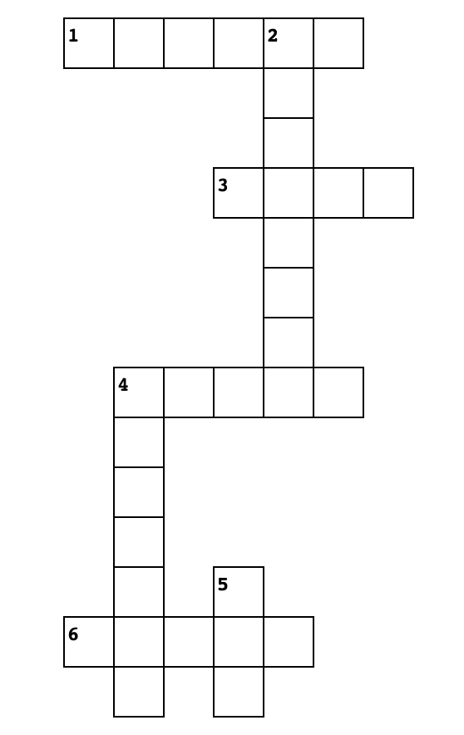
Across

1 silný
3 bohatý
4 malý
6 kouzelný

Down

2 národní
4 speciální
5 velký

