- Match A to B.
A | B
- education | - a school for students aged 11 - 18
- a boarding school | - a better school which you pay for
- a private school | - a school for pupils aged 4 - 11
- a secondary school | - the process of learning and teaching
- a primary school | - a school where children get education, accommodation, and food

2. Listen and fill in the gaps.
Families can decide between _____________ schools and state schools. It is expensive to send children to private schools because they aren’t financed by the state. Private schools are often _____________ schools, and children usually get a better _____________. When children go to a state school, they do not pay for it. These schools are usually near their _____________.

3. Fill in the gaps.
Students in England wear school ___________. They can go to ___________ schools, where they pay, or to _____________ schools, which are free. Children must start going to ____________ school at the age of __ or ____. Then they go to _____________ school, where they take exams called A-levels or BTEC. After secondary school, students go to ____________ or to ________.
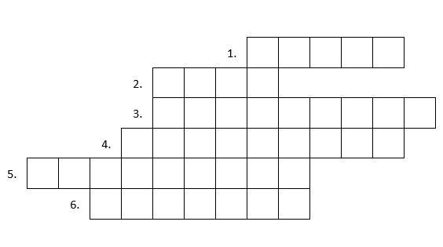
4. Fill in the crossword.
1. The schools families do not pay for

2. Practical qualification students get
after secondary school

3. The first degree students can get
at university

4. The highest
university qualification

5. The first year
of primary school

6. Academic qualification
students get at secondary school

