- Tick () what is true.
  - All mushrooms are healthy.
  - Some mushrooms are superfoods.
  - Some mushrooms are healthy.
  - Some mushrooms can make you sick.
  - Some mushrooms can kill you.
  - There are no vitamins in mushrooms.

- Which healthy mushrooms can you find in Czech forests? Circle.
oyster mushroom lion’s mane chanterelle shiitake boletus portobello enoki reishi

- Label the mushrooms.
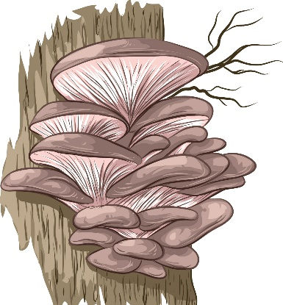 | 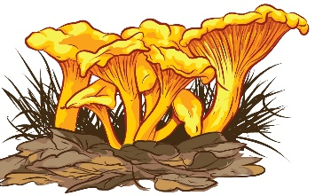 | 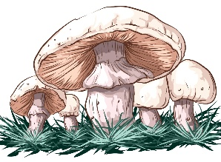 | 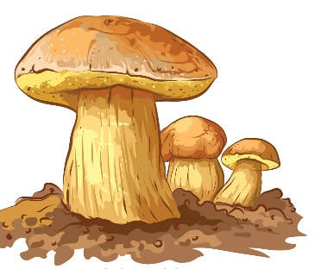
- O _ _ _ _ _ M _ _ _ _ _ _ _ | - C _ _ _ _ _ _ _ _ _ | - W _ _ _ _ M _ _ _ _ _ _ _/  P _ _ _ _ _ _ _ _ _ | - B _ _ _ _ _ _

- Listen about white mushrooms, boletus and oyster mushrooms and fill in the gaps.
WHITE MUSHROOMS: You ___ get fresh white mushrooms, also called portobello, in shops all
___ round. But you can also find their “sisters” in Czech forests and meadows in ____ and autumn.
BOLETUS: You ____ usually get fresh boletus in shops. So, go to the __________ and find them yourself. Now is the best time.
OYSTER MUSHROOMS: You can ____ oyster mushrooms in shops all year ____, but you can also find them in Czech forests in ____ and winter. You can ____ oyster mushroom pills in pharmacies.

SOLUTIONS
- Tick () what is true.
- All mushrooms are healthy.
- Some mushrooms are superfoods.
- Some mushrooms are healthy.
- Some mushrooms can make you sick.
- Some mushrooms can kill you.
- There are no vitamins in mushrooms.

- Which healthy mushrooms can you find in Czech forests? Circle.
oyster mushroom lion’s mane chanterelle shiitake boletus portobello enoki reishi

- Label the mushrooms.
- OYSTER MUSHROOM | - CHANTERELLE | - WHITE MUSHROOM/  PORTOBELLO | - BOLETUS

- Listen about white mushrooms, boletus and oyster mushrooms and fill in the gaps.
WHITE MUSHROOMS: You can get fresh white mushrooms, also called portobello, in shops all
year round. But you can also find their “sisters” in Czech forests and meadows in summer and autumn.
BOLETUS: You can’t usually get fresh boletus in shops. So, go to the forest and find them yourself.
Now is the best time.
OYSTER MUSHROOMS: You can buy oyster mushrooms in shops all year round, but you can also find them in Czech forests in autumn and winter. You can get oyster mushroom pills in pharmacies.

