- Tick () what is true.
  - All mushrooms are healthy.
  - Some mushrooms are superfoods.
  - Some mushrooms are healthy.
  - Some mushrooms can make you sick.
  - Some mushrooms can kill you.
  - There are no vitamins in mushrooms.

- Which healthy mushrooms can you find in Czech forests? Circle.
oyster mushroom lion’s mane chanterelle shiitake boletus portobello enoki reishi

- Label the mushrooms.
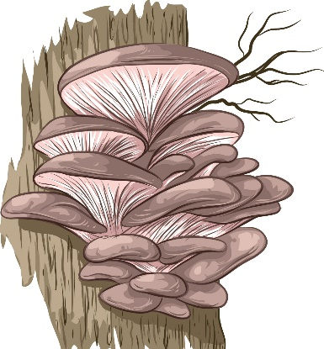 | 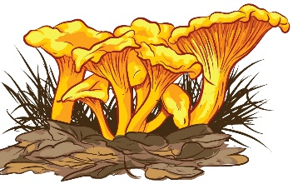 | 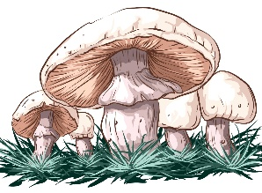 | 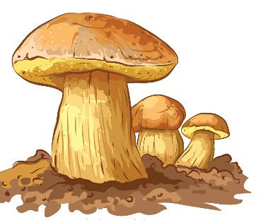
- O _ _ _ _ _ M _ _ _ _ _ _ _ | - C _ _ _ _ _ _ _ _ _ | - W _ _ _ _ M _ _ _ _ _ _ _/  P _ _ _ _ _ _ _ _ _ | - B _ _ _ _ _ _

- Listen about white mushrooms, boletus and oyster mushrooms and fill in the gaps.
WHITE MUSHROOMS: You ___ get fresh white mushrooms, also called portobello, in shops all
___ round. But you can also find their “sisters” in Czech forests and meadows in ____ and autumn.
BOLETUS: You ____ usually get fresh boletus in shops. So, go to the __________ and find them yourself. Now is the best time.
OYSTER MUSHROOMS: You can ____ oyster mushrooms in shops all year ____, but you can also find them in Czech forests in ____ and winter. You can ____ oyster mushroom pills in pharmacies.

