- Sort out: moss, gloves, saw, pliers, hot glue gun, pebbles, sand, soil.
Tools | Safety clothes | What you put inside the bulb

- Fill in missing verbs: take out, put (2x), cut off, glue, wear, add (2x), water,
Then listen and check.
- ___________ the metal end of the bulb. Be careful! Wear gloves.
- ___________the inside of the bulb.
- ___________ the bulb on the wood.
- ___________ sand inside the bulb.
- ___________ pebbles inside the bulb.
- ___________ soil.
- ___________ moss.
- ___________ it once a week.

- Match the pictures to the instructions 1 – 5. in exercise 2. Write 1 to 5.
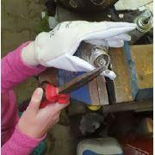 | 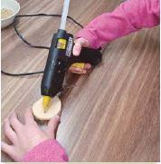 | 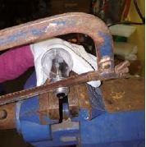 | 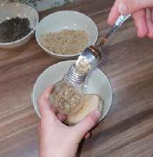 | 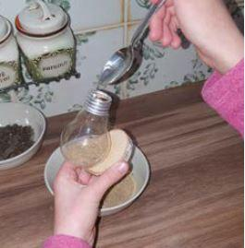

SOLUTIONS
- Sort out: moss, gloves, saw, pliers, hot glue gun, pebbles, sand, soil.
Tools | Safety clothes | What you put inside the bulb
saw | gloves | moss
pliers |  | pebbles
hot glue gun |  | sand
 |  | soil

- Fill in missing verbs: take out, put (2x), cut off, glue, wear, add (2x), water,
Then listen and check.
- Cut off the metal end of the bulb. Be careful! Wear gloves.
- Take out the inside of the bulb.
- Glue the bulb on the wood.
- Put sand inside the bulb.
- Put pebbles inside the bulb.
- Add soil.
- Add moss.
- Water it once a week.

- Match the pictures to the instructions 1. – 5. in exercise 2. Write 1 to 5.
2 | 3 | 1 | 5 | 4

