- Label the pictures: pipe cleaners, wooden spoon, thread, pan, bowl, wooden skewer.
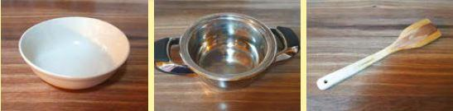

- ____________ b. ____________ c. ____________
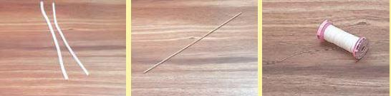

d. ____________ e. ____________ f. ____________

2. For this DIY, you also need these. Complete the words.
S _ _ _ _ _ _ _ W _ _ _ _ S _ _ _

- Match the rhymes.
mix | sip
cut | fix
dip | shut
- Fill in the gaps with: cut, mix, stir, wait, fix, pour, bend, dip. Then listen and check.
- ________ 1 litre of hot water with 250g of salt.
- ________ and wait. All the salt must dissolve.
- ________ the pipe cleaner into three parts.
- ________ the pipe cleaner in half and form a star with six points.
- ________ the salt water into a bowl.
- ________ the star into the salt water.
- ________ it onto the bowl.
- ________ for two weeks.

