- Match the opposites.
new | dry
wet | on the top
on the bottom | big
small | old/ used

- Fill in the verbs: put (2x), wait, add, mix, make, flip. Then listen and check.

- _______ small pieces of used paper in a bowl with water.
- After two hours, _______ the paper and water with a mixer.
- _______ a tea towel on the top of the new, wet paper.
- _______ it flat using a rolling pin.
- _______ the paper. The tea towel is now on the bottom.
- _______ decorations, for example dry flowers.
- _______ for the paper to dry.

- Circle what you need to make handmade paper.
used paper/ just paper a shit of clean paper/ a sheet of clean paper
a kitchen mixer/ a chicken mixer a tea tower/ a tea towel
a drainer/ rain a rocking pin/ a rolling pin

- Label the pictures.
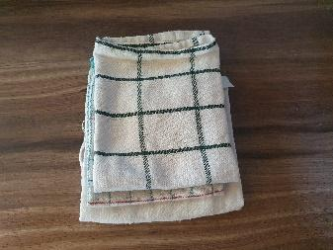 | 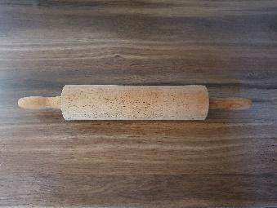 | 
       

